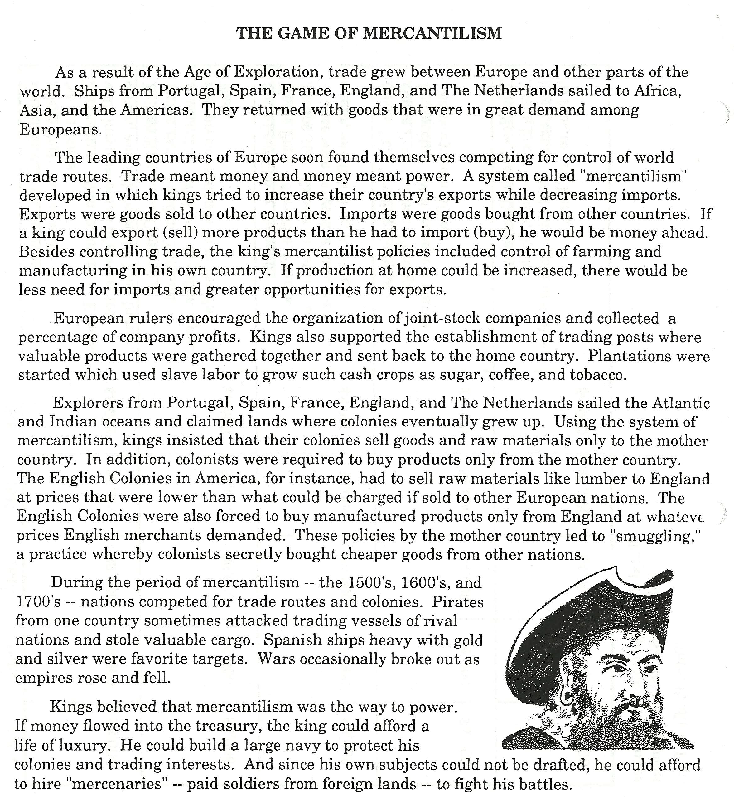

Rules for the Game of Mercantilism

1. There will be 5 groups representing the major world powers during the 1500s, 1600s and 1700s; Portugal, Spain, France, Netherlands and England. Circle the name of your group on the “group sheet”.

2. Each group will secretly choose an area of the world to travel to and write the name of the place on the top half of the group sheet under “Round 1”. Then, place the name of the commodity (product) at that location on the bottom half of the sheet.

3. After each group has made their choice, a representative will hand the group sheet to the teacher. The teacher will then announce the first county’s trade route. If no other group has chosen the same trade route and product, that first group will have established a successful trade route and gain the points from that area, represented by the number in parentheses on the map next to that product. The product chosen will then be crossed out on the map and not be chosen again.

4. If 2 or more groups choose the same trade route, then no groups gain the points! That product will not be crossed out and can be chosen again.

5. This process will be repeated until 10 rounds are played. The team with the most money at the end is the winner and will be awarded a prize.

Group Sheet

